HBH ELT 8/22/17 Team Capacity Assessment

Capacity Assessment | HBH | Norm
A Clear, Elevating Goal
1. We have a clear understanding of the mission and goals. | 3.7 | 2.8
2. We view our mission and goals as important or worthwhile. | 3.8 | 3.4
Average | 3.7 | 3.1
A Results Driven Structure
3. We have clear roles and accountabilities. | 2.8 | 2.3
4. We have an effective communication system where credible information is easily accessible to all our ELT members. | 2.2 | 2.5
5. We have an effective communication system where opportunities exist for team members to raise issues not on the formal agenda. | 3.0 | 2.6
6. We have an effective communication system to document issues raised and decisions made. | 2.8 | 2.8
7. We monitor Individual performance and provide feedback. | 2.5 | 1.8
8. We make decisions based on sound facts and interpreted without the harness of predisposition. | 2.8 | 2.8
Average | 2.7 | 2.5
Competent Team Members
9. We possess the relevant skills, abilities, and knowledge. | 3.8 | 2.9
10. We possess a strong desire to make a meaningful difference to the cause. | 4.0 | 3.4
11. We are capable of working well with each other. | 3.3 | 3.2
Average | 3.7 | 3.1
Unified Commitment
12. We make serious individual investments of time and energy. | 4.0 | 2.6
13. We do not pursue individual objectives at the expense of the cause. | 3.5 | 3.2
Average | 3.7 | 2.9
A Collaborative Climate
14. We have a climate of honesty – integrity, no lies, and no exaggerations. | 3.5 | 3.3
15. We are open: a willingness to share, a receptivity to information, perceptions, ideas. | 2.8 | 3.1
16. We are consistent: predictable behavior and responses. | 2.7 | 2.9
17. We are respectful: treating people with dignity and fairness. | 2.8 | 3.4
Average | 3.0 | 3.2
Standards of Excellence
18. Our standards of performance are clearly and concretely articulated. | 3.0 | 2.3
19. Individual members require one another to conform to the established standards. | 2.2 | 2.3
20. We exert pressure to make changes that constantly improve our standards. | 2.7 | 2.3
Average | 2.7 | 2.3
External Support and Recognition
21. We celebrate our successes and have the tools we need to do our jobs. Average | 3.1 | 3.0
Principled Leadership
22. We keep the vision of the future alive and in mind. | 3.5 | 2.8
23. We inspire our ELT to make changes when needed. | 3.0 | 2.7
24. We unleash the energy and talents of our ELT members. | 3.3 | 2.4
25. We suppress our individual egos on behalf of all of our ELT members. | 2.8 | 3.0
Average | 3.2 | 2.7
Average | 77.1 | 68.7
Open-ended Questions

Like About Our ELT | Don’t Like About Our ELT
- As a group it responds well to emergency /urgencies.  - I think supportive and there for each other many times although not all the time.  - Regular meetings, some processes in place in terms of note taking and we do get a lot done at the end of the day.  - Everyone is smart, dedicated, focused on maximizing our contribution to the community  - Talented group  - Howard Brown's ELT is passionate about Howard Brown's mission.  - The team works extraordinarily hard, is creative and open to new ideas.  - Passion, skills, commitment  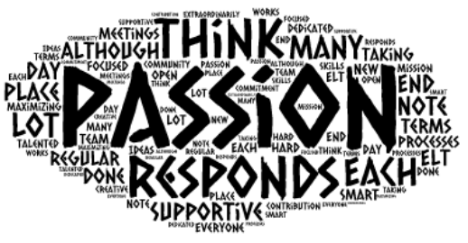 | - I see three main challenges:  - Lack of agreement on the scope of responsibilities for individual ELT roles.  - Unpopular or contentious decisions held for ransom or get stuck in the process with in my experience  - Formative discussions happening without people who have direct knowledge of the issue in the room.  - Sometimes we could listen better (to each other and others in the org.  - Following decision making, we do not always set clear goals for follow up and monitoring.  - In addition, we could work more effectively on inter-departmental projects.  - Trust in each other is not always there.  - We all work independently and do a good job at our individual tasks but there does not feel like there is much cohesion between us.  - We're all doing a ton of work but we don't really know what the others are working on and how we all fit together.  - Some of us are told to "stay in our lanes" and others seemingly can do whatever they want even if it has nothing to do with their job. That wouldn't be a bad thing if we had more of a sense of collaboration.  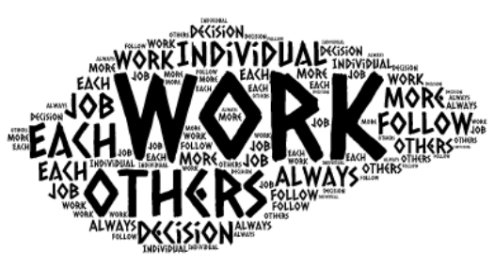

Like About Being a Member | Don’t Like About Our ELT
- There is a great deal of flexibility  - I enjoy ELT members and their contributions and their different personalities.  - Allows me to support the organization and its goals  - ability to influence change  - I enjoy and learn from my colleagues.  - I get satisfaction from knowing that Howard Brown has an incredible impact on our community.  - Where the business meets the mission.  - It's challenging work.  - When we do well we provide an important service to the community.  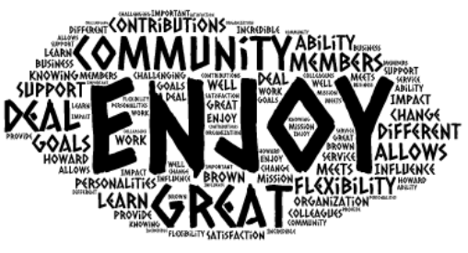 | - We are seen to argue in front of staff, the ELT isn't always perceived as respectful or honorable.  - I find it really frustrating when we have not come to a shared agreement about a project's priority and do not get support from team members. I think we could do more work up front to mitigate this.  - We arrive at decisions but not always unity. I don't mind a certain level of stress in an executive level position but this seems extreme.  - The lack of communication between us. And I often do not feel supported or valued for my expertise by my peers.  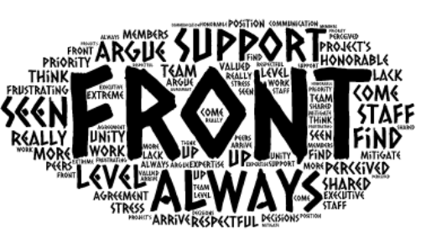

Other Comments
- More thoughtful about who should be in the room for decision making.
- More direct communication would be appreciated.
- I experience that my decisions to be rubberstamped by ELT most of the time, and doesn't appear to be the case for all of ELT.
- My response is to try and be more inclusive in decision making but to date this hasn't resulted in as much reciprocation as I would like.
- Given staff and board scrutiny, how we operate (the process, the behaviors, the values) is as important as the decisions we reach
- I think we have great potential to be a very effective ELT but we need more cohesion, more collaboration, and more communication. We need to bond as a team more. And we need to trust each other more.
- It's much better than it was but we're not there yet
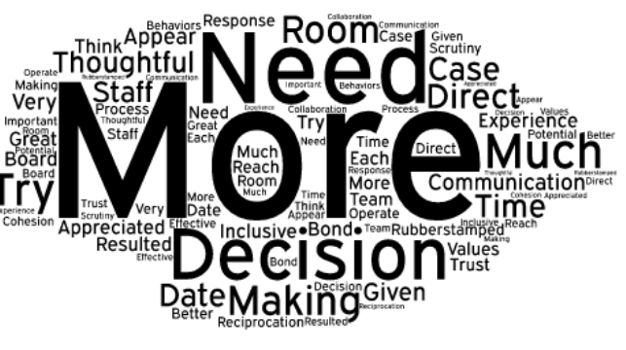

.

Adapted by Mark Light from Larson, C. E., & LaFasto, F. M. J. (1989). Teamwork: What must go right, what can go wrong. Newbury Park, CA: Sage.

